# Exercise 1: MLP in Eager Mode – Group 24

## Sebastian Häni [haeniseb@students.zhaw.ch](mailto:haeniseb@students.zhaw.ch), Raffael Affolter [affolraf@students.zhaw.ch](mailto:affolraf@students.zhaw.ch), Benjamin Mäder [maedeben@students.zhaw.ch](mailto:maedeben@students.zhaw.ch)

## Training with stdev_scale_glorot

Layers: 50, 50, 50, 10

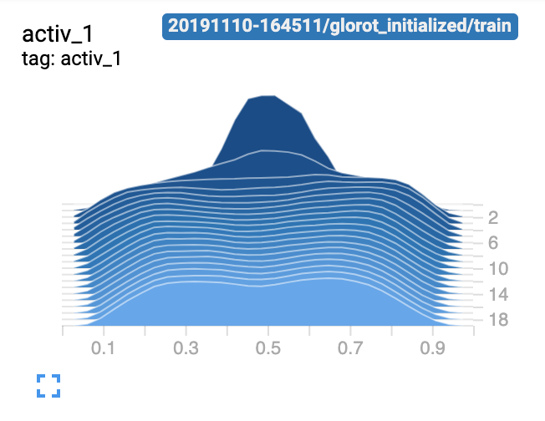

* The activations are not saturated with Glorot initialization.

## Training with no std scale initialization

Layers: 50, 50, 50, 10

* The activations clearly are saturated.

## Simple model

Now we try what happens if we simplify the model to 1 hidden layer of 50 units and an output of 10 units. We use Glorot initialization

* The activations are clearly saturated even though we used Glorot initialization. The model didn’t learn well because it cannot cope with the data complexity as it’s too simple.

## Complex model

Now we try what happens if we use a model with 5 hidden layers of 20 units and an output of 10 units. We use Glorot initialization.

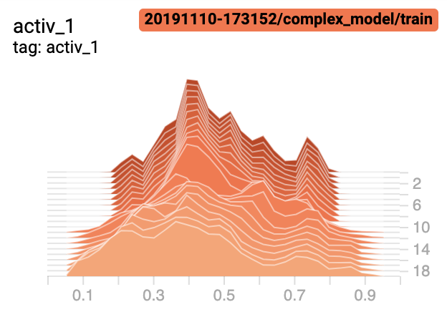

* Even though there is no saturation, the layers had too few units to properly fit the model.